Using Rubrics to Grade Assignments 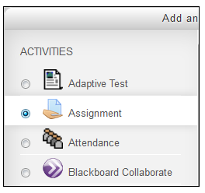
Rubrics are grading forms used for criteria-based assessment. The rubric consists of a set of criteria. For each criterion, several descriptive levels are provided. A numeric grade is assigned to each of these levels.

Contents
- Create a Rubric Form
- Use the Rubric
- Use a Rubric for Another Assignment in the Same Course
- Edit a Rubric / Delete a Rubric
- More information
Create a Rubric Form
- Go to the course home page.
- Click on the Assignment activity you have created.
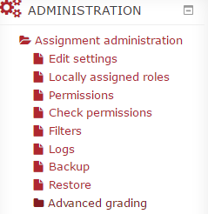
- Click Advanced grading under the Administration block.

- The Advanced grading page will appear.
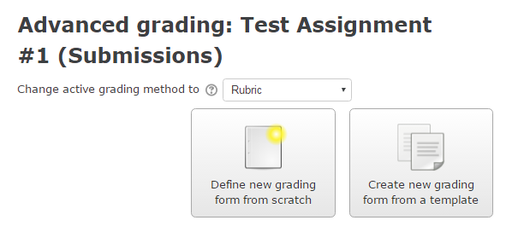

- Set Rubric for "Change active grading method to".
- Click Define new grading form from scratch. If you want to use a template, choose Create new grading form from a template.
The setting page will appear.
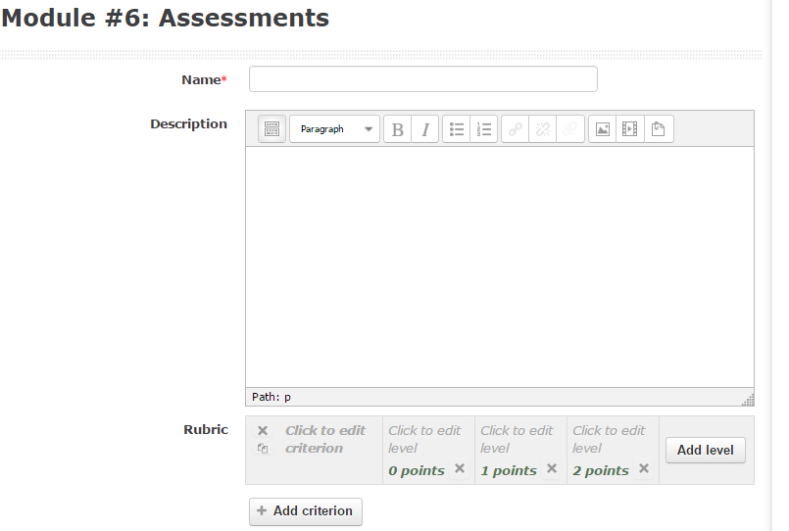
- Type a Name for the Rubric. The Rubric Name should help you identify the skills the rubric is assessing in case you want to re-use or edit the rubric for other assignments. The Description is optional.
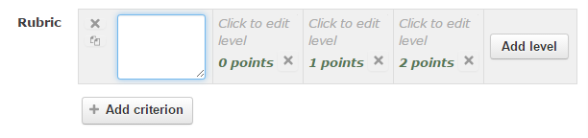
- Click inside of the Rubric.

- The text box will appear.
* Always include a level of 0 points in the rubric definition. (To get more information click here (moodle.org)
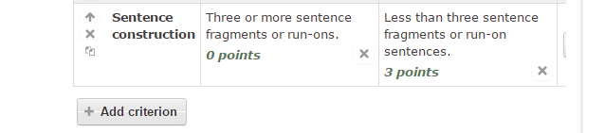
- Type a Criterion, Level and Points.
Criteria
Levels
Points

* Use the Tab key to jump to the next level/criteria.
10. Add new criterion or level by clicking on the Add criterion button or Add level button.
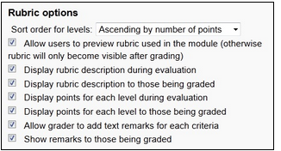
11. Choose the Rubric options.

12. Click on the Save rubric and make it ready button.
Using the Rubric
When using the rubric to assess a student’s work, you can click on the level describing the student's performance. The selected levels will become light green. A level must be selected for each criterion, otherwise the rubric is not validated by the server as the final grade cannot be calculated.
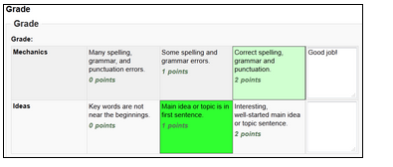

Use a Rubric from Another Assignment for Which You Have a Teacher Role In Moodle
- Click on the assignment.
- Click on Advanced grading under the Administration block.
- Click on the Create new grading form from the template button.
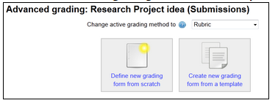
- Check the include my own forms checkbox and click on the Search button.
The Rubrics that you create will appear.
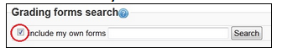

- Choose the Rubric by clicking the Use this form as a template button next to the Rubric.
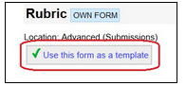
- Click on the Continue button.

To Edit a Rubric / Delete a Rubric
- Go to the course home page.
- Click on the Assignment activity.
- Click Advanced grading under the Administration block.
- To edit the Rubric: Click on the Edit the current form definition button.
To delete the Rubric: Click on the Delete the currently defined form.
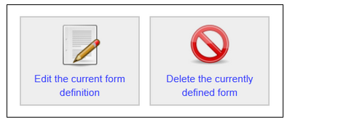

For more information See Advanced grading Methods in Moodle.org docs or contact Moodle Help

